THE SIGN OF THE CROSS – The Sign of the Cross is one of the most common and simple prayers we often say, and it also one of the most powerful prayers. By making the Sign of the Cross we express our desire to be faithful to God. We do not desire to live according to the standards of this world, but to have our whole lives marked by Christ's cross.
Ezekiel 8:3-17: Abominations in the Temple.
Ezekiel 9:1-8: The “Sign” sets the righteous apart. The sign is the Hebrew letter taw written on the forehead. In cursive Hebrew, taw is written .
We also invoke the power of God’s name (not names, there is only OBE God in three divine persons, the Trinity). To call upon the name of God is to invoke his presence. There is power even in God’s name. This is why God commands us to never call upon his name in vain (the second commandment):
Psalm 54:2 – “O God, by your name save me.”
Philippians 2:10 – “… at the name of Jesus every knee should bend…”
Matthew 18:20 – “For where two or three are gathered together in my name, there am I in the midst of them.”
John 14:13 – “And whatever you ask in my name, I will do…”
When we make the Sign of the Cross, we:
- Acknowledge Jesus as Lord
- Invoke His presence
St. Cyril of Jerusalem (fourth century):
“Let us then not be ashamed to confess to the Crucified. Let the cross as a seal be boldly made with our fingers upon our brow and on all occasions; over the bread we eat, over the cups and drink, in our comings and goings, before sleep, on lying down and rising up, when we are on our way and when we are still. It is powerful safeguard, it is without price, for the sake of the poor; without toil, because of the sick; for it is a grace from God, a badge of the faithful, and terror to the devils … Despise not the seal as a free gift, but rather for the reason honor your benefactor all the more.”
A FANTASTIC little book Fr. Andreas Andreopoulos, The Sign of the Cross – The Gesture, The Mystery, The History, Brewster, MA: Paraclete Press, 2006.

Other Ancient Symbols:
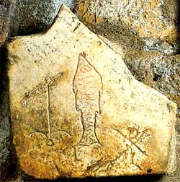
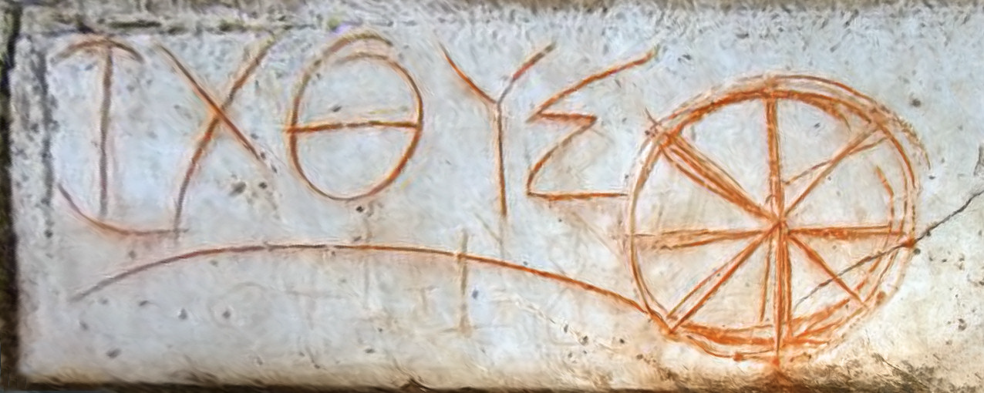
ἰχθύς – fish – acrostic: Ίησοῦς Χριστός, Θεοῦ Υἱός, Σωτήρ (Jesus Christ, Son of God, Savior)

From early Ephesus:

From the catacomb of St. Sebastian (martyred c 288):
For Jews, who may not say or write God’s name (today they write G-d), the letter taw (cursive: 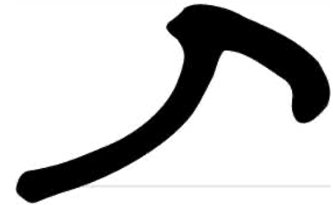 ) was used as a representation of God’s name. It’s the last letter in the Hebrew alphabet and symbolizes the end, completion, and perfection.
Some early icons (note the mark of the cross on the forehead):

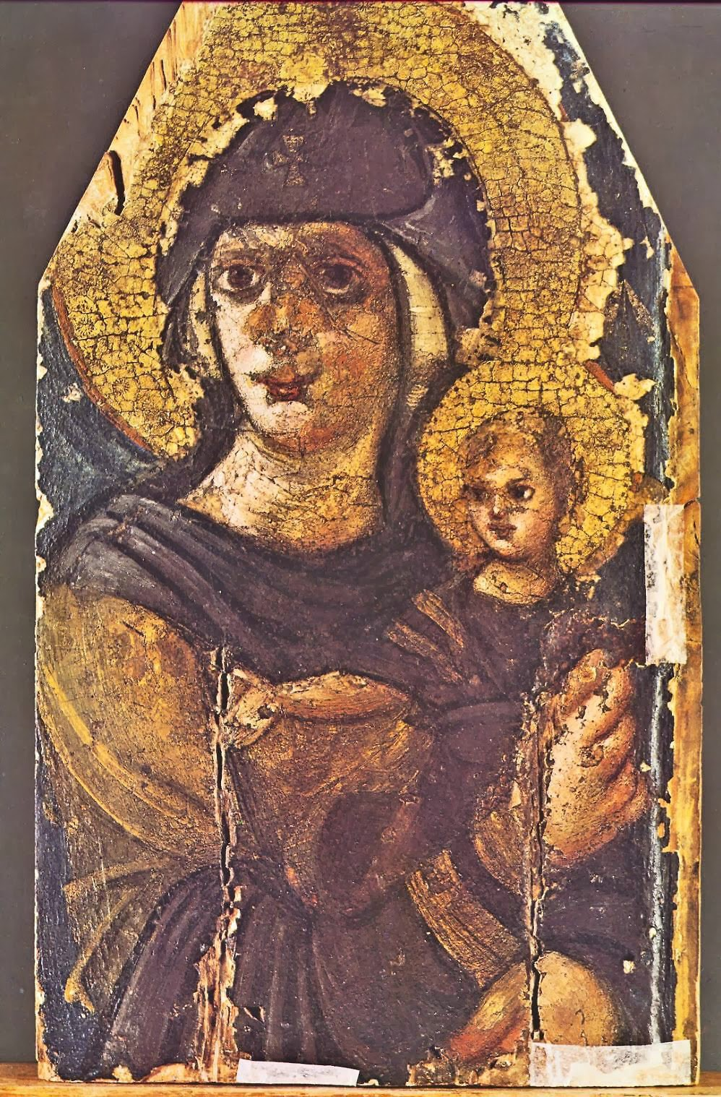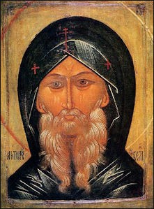
A “mark” is sometimes a negative thing in the Old Testament. Cain is “marked” (see Genesis 4:15) “So the LORD put a mark on Cain, so that no one would kill him at sight.”
A sore on the forehead could mark a person as unclean. See Leviticus Chapter 14. (Recall our discussion above on Ezekiel.)
In the New Testament:
Revelation 14:1:
Then I looked and there was the Lamb standing on Mount Zion, and with him a hundred and forty-­‐four thousand who had his name and his Father’s name written on their foreheads.
Revelation 22:4:
They will look upon his face, and his name will be on their foreheads.
The Hebrew Aleph, the first letter of the Hebrew alphabet.
It represents truth. In both Hebrew and Aramaic script, it looks like a cross. Early Christians associated it with John’s gospel where Jesus says, “I am the way, the truth, and the life.”
The first and last letters are strongly connected in Jewish theology.
The Hebrew word for “truth” is אמת “emet” aleph-­‐mem-­‐taw, the first, middle, and last letter of the alphabet.

The first letter of the Greek alphabet is alpha (A) and the last is omega (Ω).
Revelation 22:13 -­‐ I am the Alpha and the Omega, the first and the last, the beginning and the end.”

We often see the superposed Greek letters AΩ:
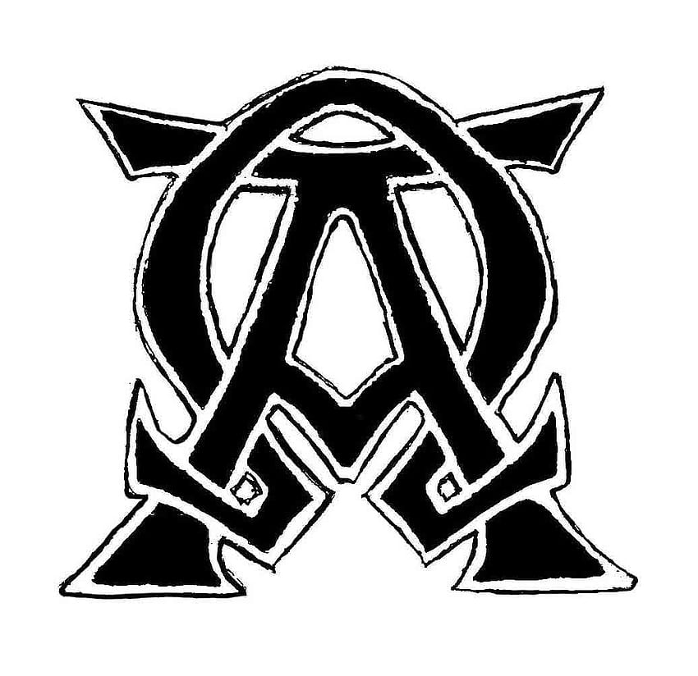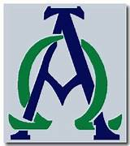
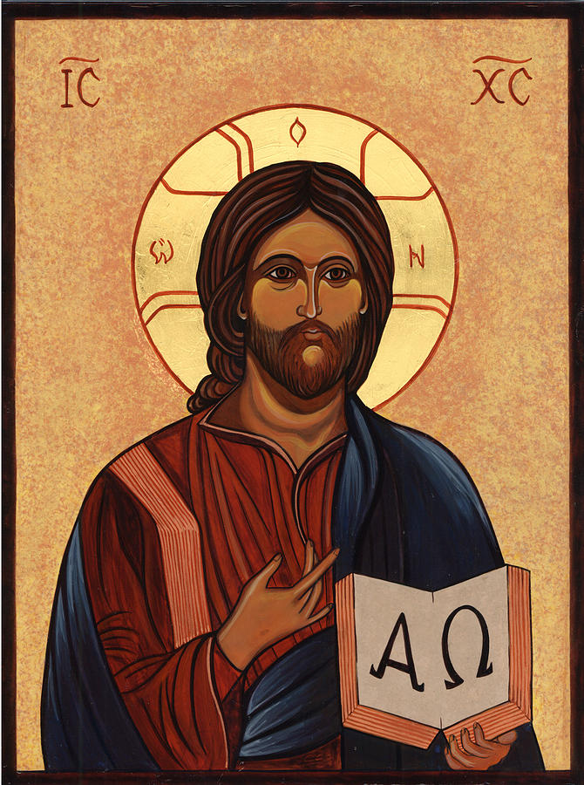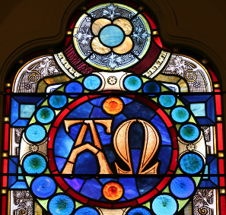
Jesus Christ is the truth, the alpha and the omega, the aleph and the taw. In His person the truth and perfection were fused on the cross. He is the beginning and the end, the manifestation of absolute perfection. Christ in Greek is Χριστός, hence the superposed Χρ.
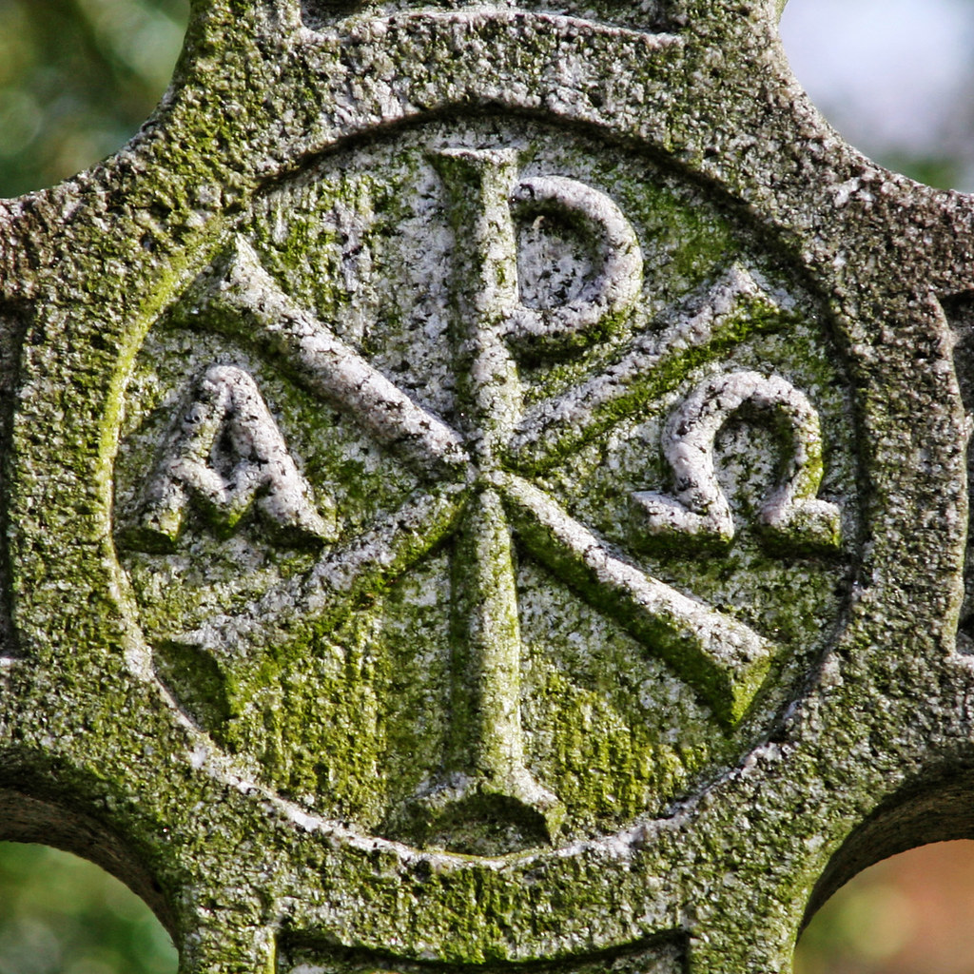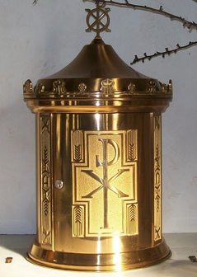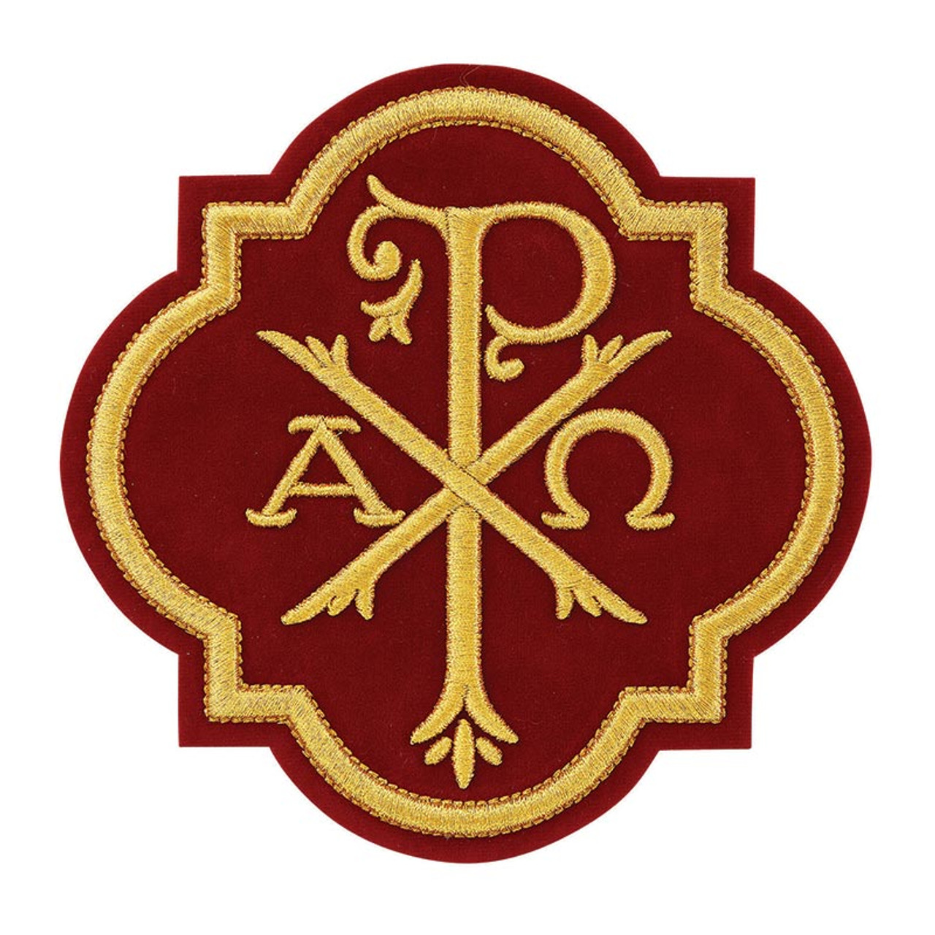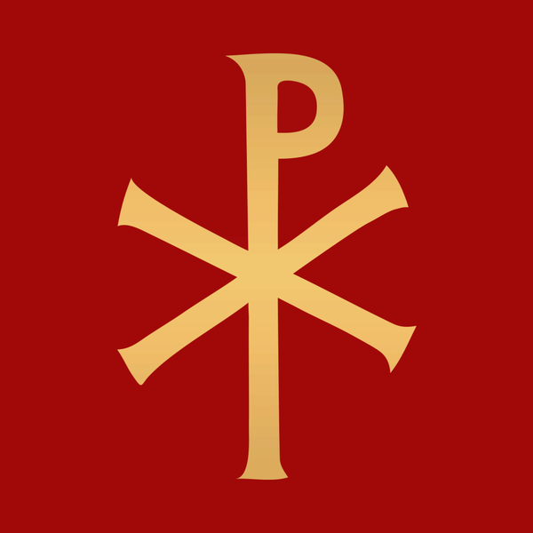
An early image of Christ Pantocrator (Παντοκράτωρ) meaning Almighty or All-powerful was used as a translation of one of many names of God in Judaism.
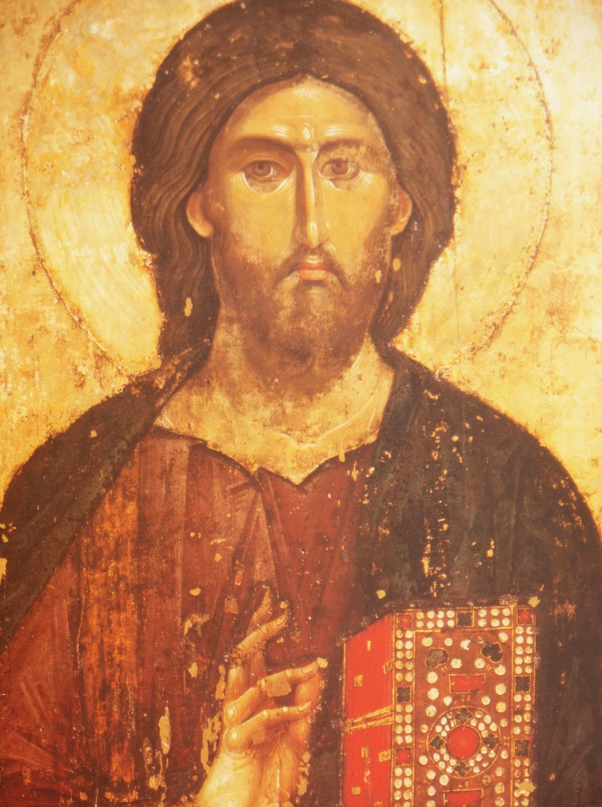

When the Hebrew Bible was translated into Greek as the Septuagint, Pantokrator was used both for YHWH Sabaoth "Lord of Hosts" and for El Shaddai "God Almighty". The author of the Book of Revelation uses the word Pantokrator to be reserved for God alone.

