THE SIGN OF THE CROSS Revised 4/22/26
In the name of the Father, and of the Son, and of the Holy Spirit.
Spirit (πνεῦμα, pneuma) is correct, not ghost (φάντασμα, phantasma). Why?
The Sign of the Cross is one of the most common and simplest prayers we pray, and it is also one of the most powerful, a prayer by itself. It is sometimes called “The Silent Prayer,” since no words need be said. By making the Sign of the Cross, we express our desire to be faithful to God, not living according to the standards of this world, but to have our whole lives marked by Christ's cross. The roots of the Sign of the Cross go back to the Old Testament.
Ezekiel 8 describes abominations taking place in the Temple, resulting in the Lord departing from it. Ezekiel 9:1-8 (an apocalyptic text) reads:
“… the LORD said to him [a scribe dressed in linen]: Pass through the city, through the midst of Jerusalem, and mark an X on the foreheads of those who grieve and lament over all the abominations practiced within it. To the others he said in my hearing: Pass through the city after him and strike! Do not let your eyes spare; do not take pity. Old and young, male and female, women and children—wipe them out! But do not touch anyone marked with the X. Begin at my sanctuary. So they began with the elders who were in front of the temple.”
The “Sign” sets the righteous apart. That “Sign” was the Hebrew letter taw, often written  in cursive Hebrew, written on the forehead.
For us today, names simply serve as handles. Not so in Biblical languages, where names mean something.
Names and titles in Biblical Hebrew function as linguistic vessels of theological depth and narrative design. Divine names such as Elohim, יְהוָה ,אֱלהִים (YHWH, the tetragrammaton, the unutterable name of G-d), and compound forms such as יְהוָה צְבָאוֹת encode presence, sovereignty, and covenantal fidelity, while personal names (see below) often reflect destiny or divine interaction. https://biblicalhebrew.org/the-use-of-names-titles-in-biblical-hebrew.aspx
Examples:
- "Avraham" "av," "father" and "raham," "multitude." Avraham means "father of a multitude."
- Recall the name change in Genesis 17:5, was originally “Avram” means “exalted father.”
- Yisraʾel, “He struggled with God,” or "God prevails." Israel was the new name for Jacob given to him by God after his wrestling with a divine figure. See Genesis 32:28: “What is your name?” the man asked. He answered, “Jacob.” Then the man said, “You shall no longer be named Jacob, but Israel, because you have contended with divine and human beings and have prevailed.”
- Immanuel. עִמָּנוּאֵל From im, עִם, meaning with, and 'el, עִם, meaning God, with a pronominal suffix inserted; with us (is) God. Isaiah 7:14: “Therefore the Lord himself will give you a sign; the young woman, pregnant and about to bear a son, shall name him Emmanuel.”
A common way of referring to God is Hashem, (הָשֵׁם) the Name. We also invoke the power of God’s name (not names, there is only ONE God in three divine persons, the Trinity). To call upon the name of God is to invoke his presence. There is power even in God’s name. This is why God commands us to never call upon his name in vain (the second commandment). Some examples:
- Psalm 54:2 – “O God, by your name save me.”
- Philippians 2:10 – St. Paul says: “… at the name of Jesus every knee should bend…”
- Matthew 18:20 – Jesus says: “For where two or three are gathered together in my name, there am I in the midst of them.”
- John 14:13 – Jesus says: “And whatever you ask in my name, I will do…”
- Acts 4:12 – St. Peter says: “There is no salvation through anyone else, nor is there any other name under heaven given to man by which we are to be saved.”
- Romans 10:13 – St. Paul says: “For ‘everyone who calls on the name of the Lord will be saved.’”
- Exodus 20:7 – “You shall not invoke the name of the LORD, your God, in vain. For the LORD will not leave unpunished anyone who invokes his name in vain.”
When we make the Sign of the Cross, we:
- Acknowledge Jesus as Lord
- Invoke His presence
St. Cyril of Jerusalem (fourth century):
“Let us then not be ashamed to confess to the Crucified. Let the cross as a seal be boldly made with our fingers upon our brow and on all occasions; over the bread we eat, over the cups and drink, in our comings and goings, before sleep, on lying down and rising up, when we are on our way and when we are still. It is powerful safeguard, it is without price, for the sake of the poor; without toil, because of the sick; for it is a grace from God, a badge of the faithful, and terror to the devils … Despise not the seal as a free gift, but rather for the reason honor your benefactor all the more.”
Tertullian believed the Sign of the Cross to be already universal in AD 204:
“In all our travels and movements, in all our coming in and going out, in putting off our shoes, at the bath, at the table, in lighting our candles, in lying down, in sitting down, whatever employment occupies us, we mark our foreheads with the sign of the cross.”
A great little book by the Greek Orthodox theologian, Andreas Andreopoulos, The Sign of the Cross – The Gesture, The Mystery, The History, Brewster, MA: Paraclete Press, 2006.

Other Ancient Symbols
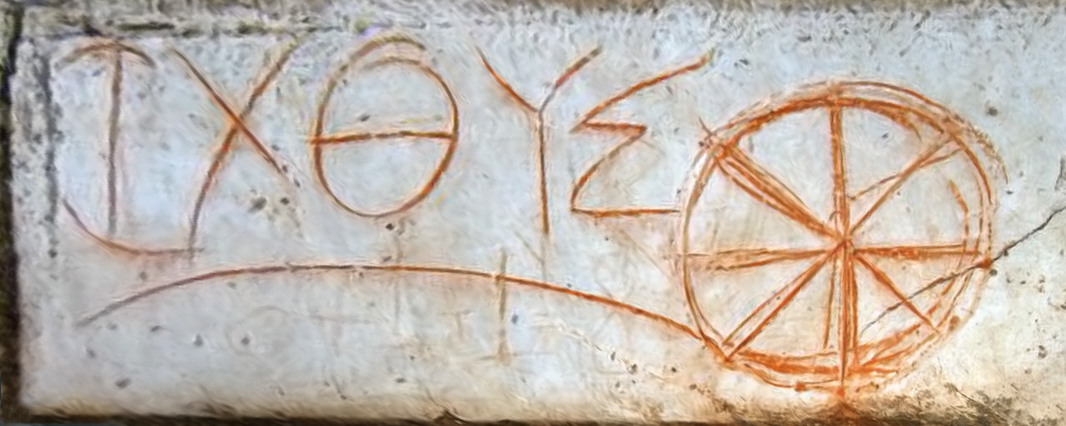
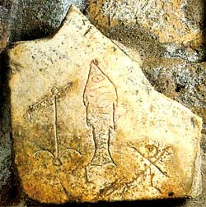
ἰχθύς – the Greek word for fish – acrostic: Ίησοῦς Χριστός, Θεοῦ Υἱός, Σωτήρ (Jesus Christ, Son of God, Savior)

From early Ephesus

From the catacomb of St. Sebastian (martyred c 288):
For Jews, who may not say or even write God’s name (today they write G-d), the letter taw (cursive: 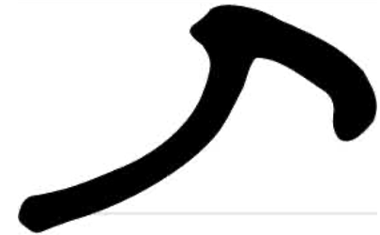 ) was used as a representation of God’s name. It’s the last letter in the Hebrew alphabet and symbolizes the end, completion, and perfection.

Some early icons (note the mark of the cross on the forehead):

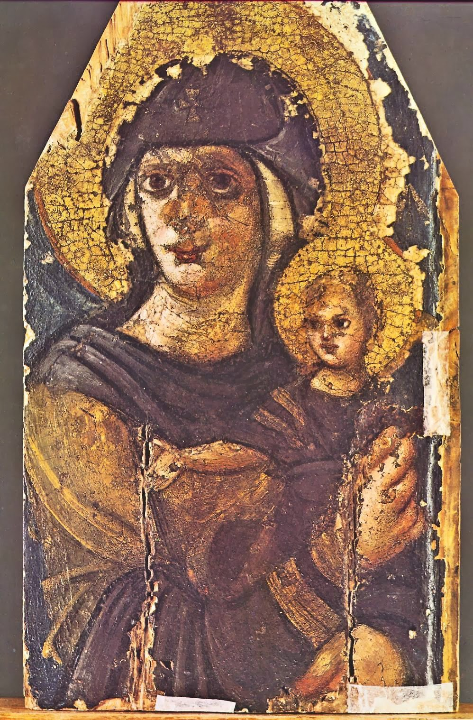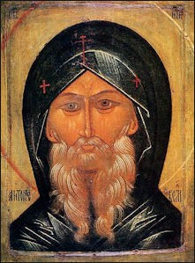
A “mark” is sometimes a negative thing in the Old Testament. Cain is “marked” (see Genesis 4:15) “So the LORD put a mark on Cain, so that no one would kill him at sight.”
A sore on the forehead could mark a person as unclean. See Leviticus Chapter 14. In the New Testament:
Revelation 14:1 (another apocalyptic text):
Then I looked and there was the Lamb standing on Mount Zion, and with him a hundred and forty-­‐four thousand who had his name and his Father’s name written on their foreheads.
Revelation 22:4:
They will look upon his face, and his name will be on their foreheads.
The Hebrew Aleph, the first letter of the Hebrew alphabet.
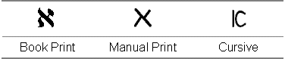
It represents truth. In both Hebrew and Aramaic, in manual print, it looks like a cross. Early Christians associated it with John’s Gospel, where Jesus says, “I am the way, the truth, and the life.”
The first and last letters are strongly connected in Jewish theology.
The Hebrew word for “truth” is אמת “emet” aleph-­‐mem-­‐taw, the first, middle, and last letter of the alphabet.
The first letter of the Greek alphabet is alpha (A) and the last is omega (Ω).
Revelation 22:13: “I am the Alpha and the Omega, the first and the last, the beginning and the end.”
We often see the superposed Greek letters, A and Ω:
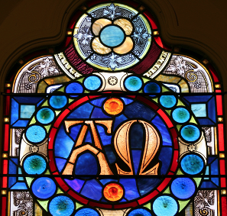
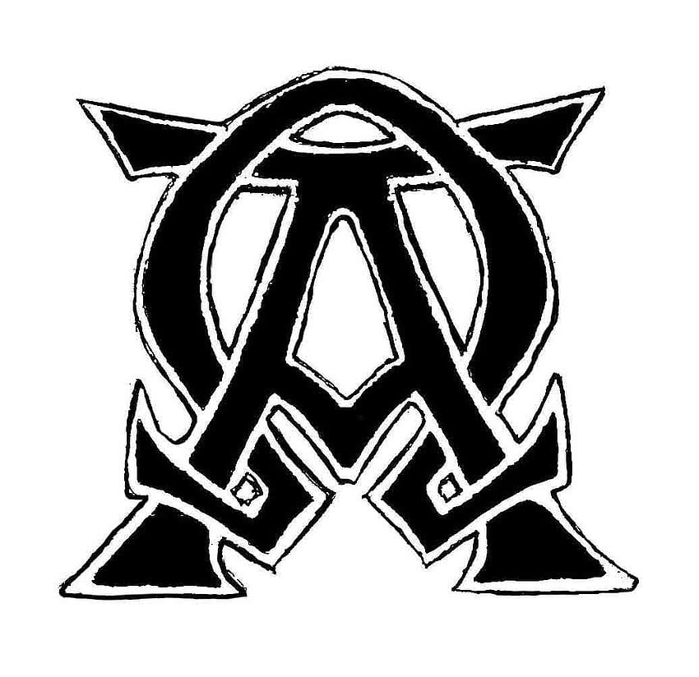
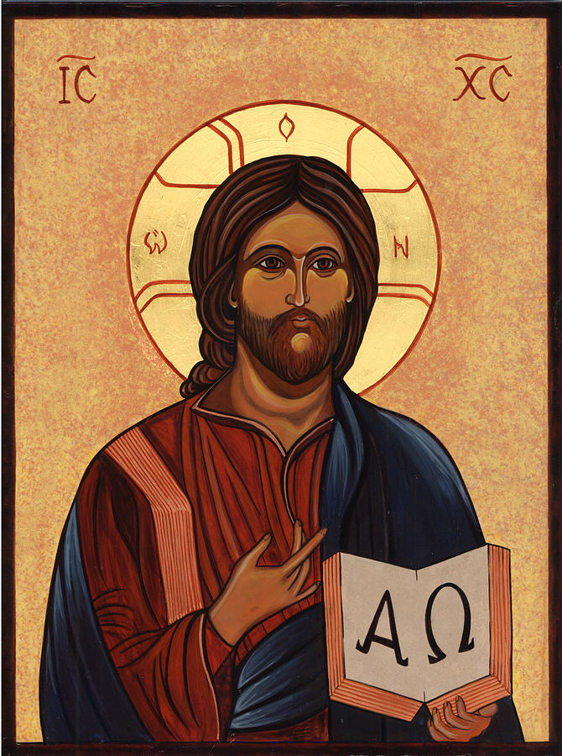
Recall the Paschal candle from the Easter Vigil, lit for every Mass during the Easter Season, at all baptisms and funerals, and kept unlit next to the baptismal font outside the easter season.
Jesus Christ is the truth, the alpha and the omega, the aleph and the taw. In His person, the truth and perfection were fused on the cross. He is the beginning and the end, the manifestation of absolute perfection.
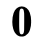
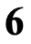
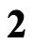
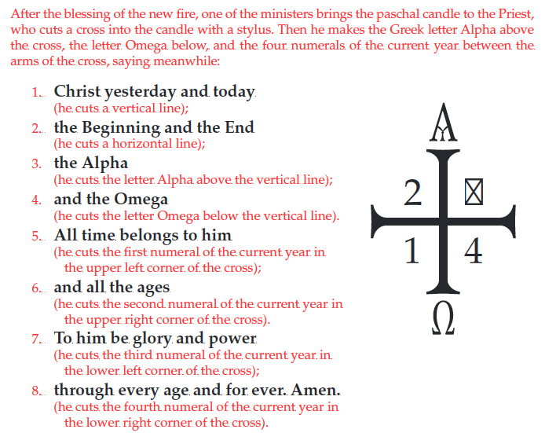
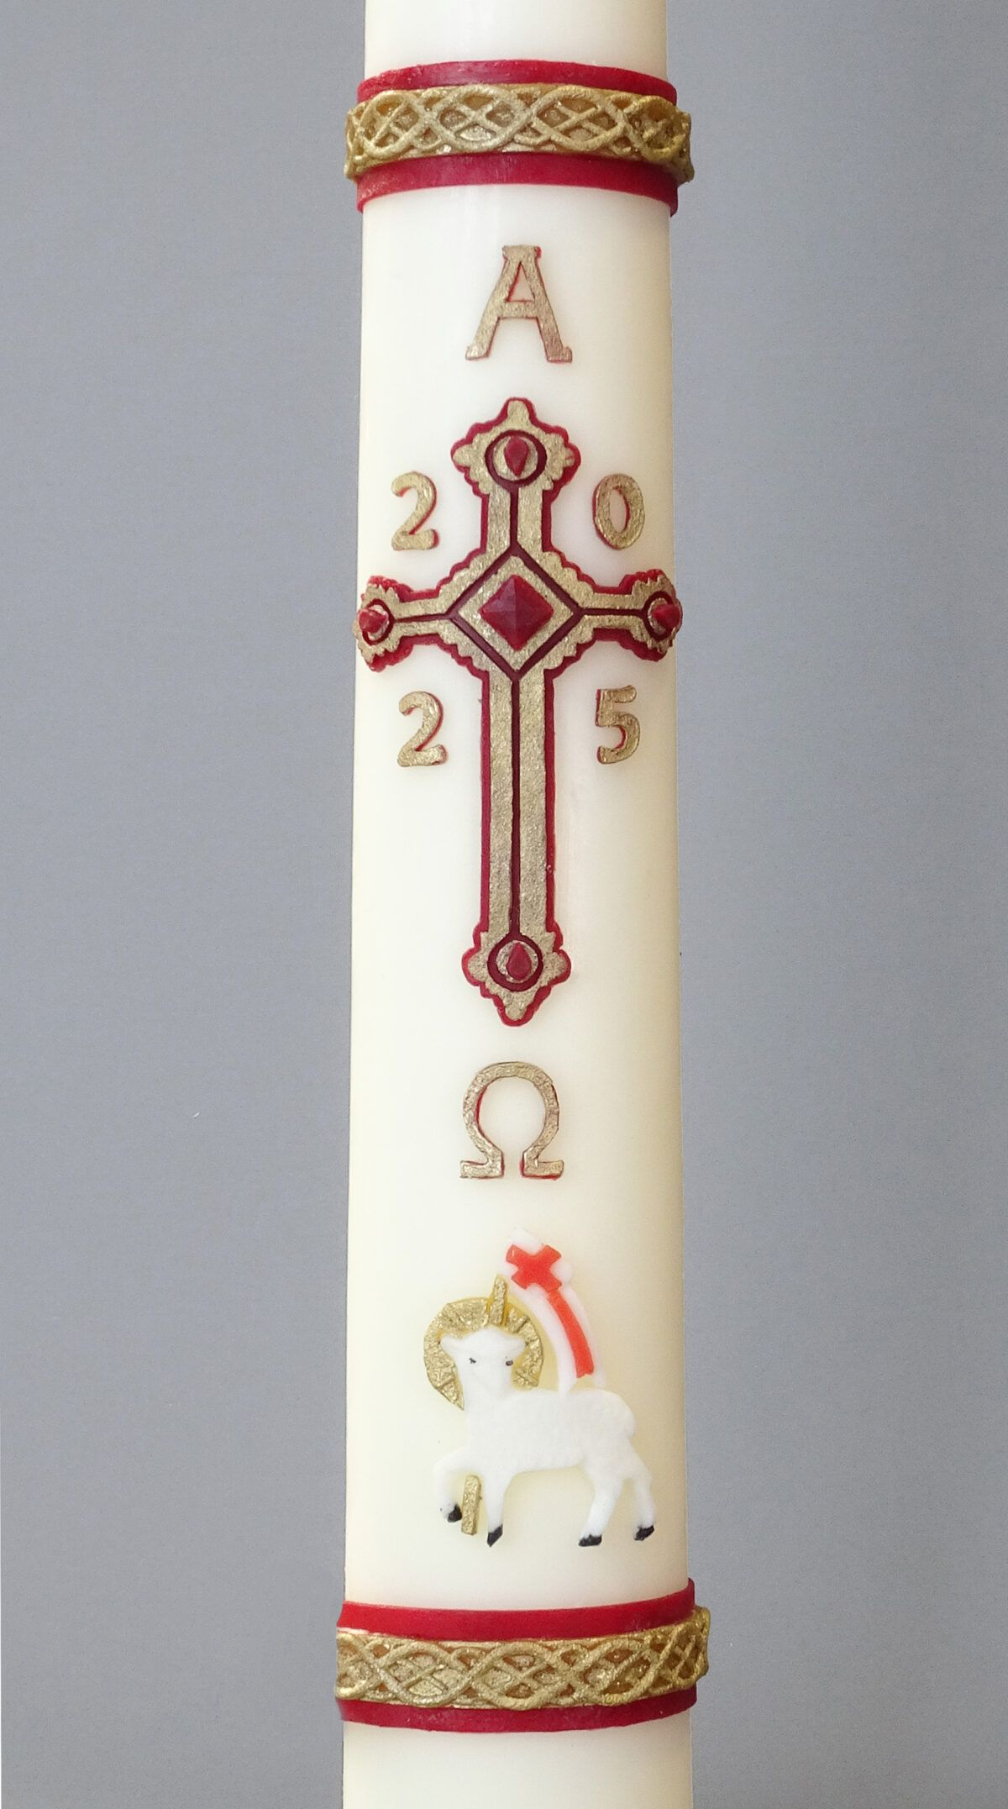

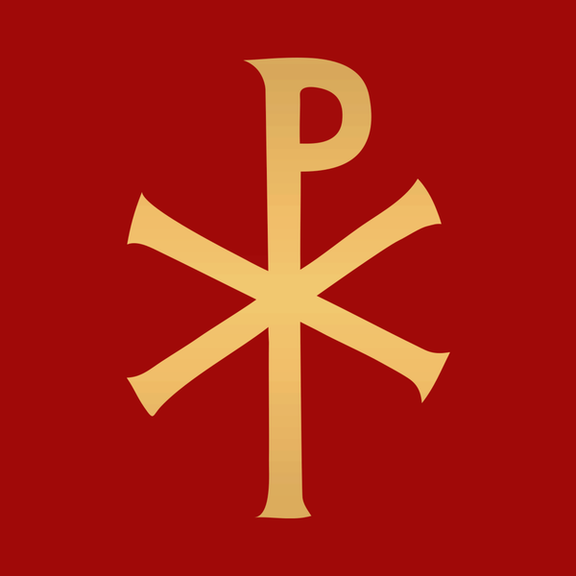
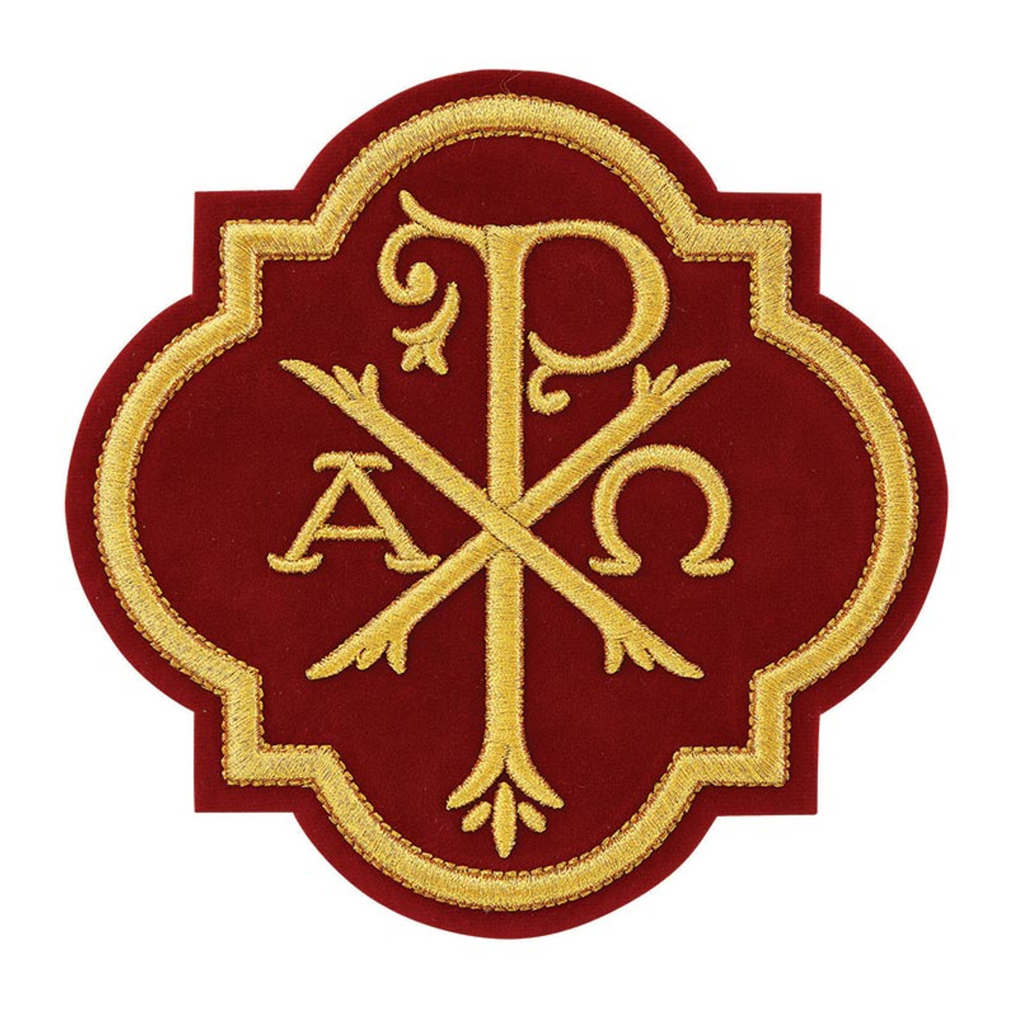
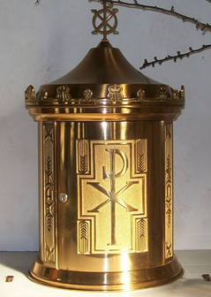
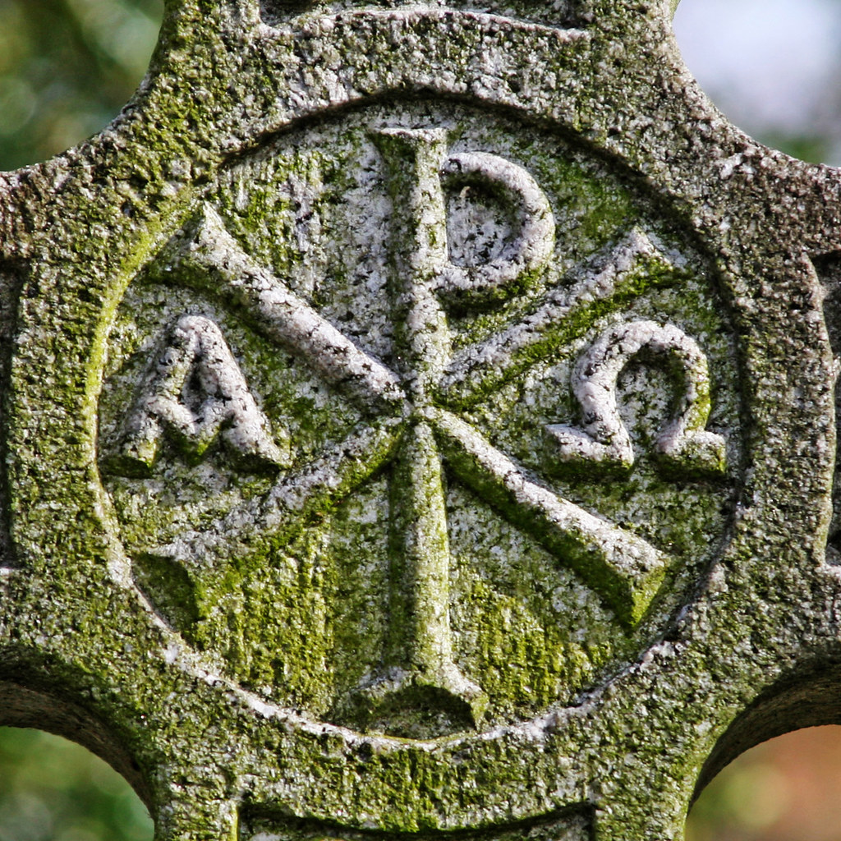
Chi Χ Rho ρ: Christ in Greek is Χριστός, hence the superposed Χρ.

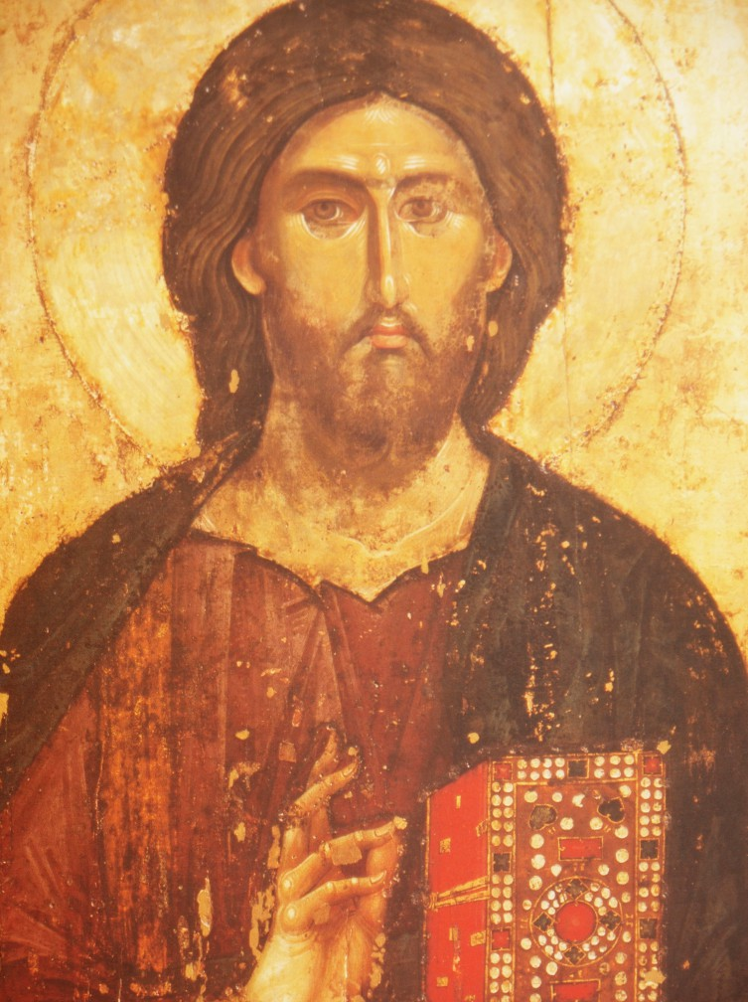
An early image of Christ Pantocrator (Παντοκράτωρ) meaning Almighty or All-powerful was used as a translation of one of many names of God in Judaism.
When the Hebrew Bible was translated into Greek, the Septuagint, Pantokrator was used both for YHWH Sabaoth "Lord of Hosts" and for El Shaddai "God Almighty". The author of the Book of Revelation reserves the word Pantokrator for God alone.
The Greek text in Revelation 4:8 has παντοκρατωρ (pantokrator) instead of Σαβαώθ (Sabaoth). Pantokrator is a word that means “powerful over all.” Revelation 4:8:
“Holy, holy, holy is the Lord God almighty, who was, and who is, and who is to come.”
The Sanctus, prayed at every Mass:
Holy, holy, holy Sanctus, Sanctus, Sanctus. Ἅγιος, ἅγιος, ἅγιος
Lord, God of hosts, Dominus Deus Sabaoth. Κύριος Σαβαώθ.
heaven and earth are full of your glory. Pleni sunt cæli et terra gloria tua.
Hosanna in the highest. Hosanna in excelsis.
Blessed is he who comes in the name of the Lord. Benedictus qui venit in nomine Domini.
Hosanna in the highest. Hosanna in excelsis.

